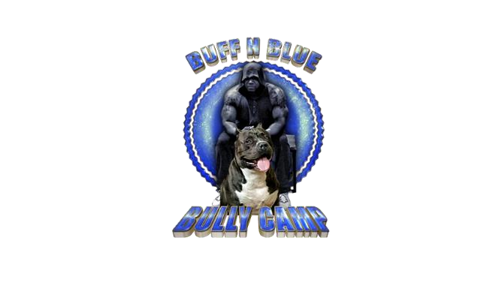

**BUFF N BLUE BULLY’S PUPPY SALES CONTRACT**

It is understood that this agreement is to protect the Buyer’s rights as well as the integrity of the Seller’s bloodlines and breeding standards.

_____________________________________________________ *(hereinafter referred to as “Buyer”)*

and Buff N Blue Bully’s *(hereinafter referred to as “Seller”)* voluntarily enter into and agree to all terms and conditions in the contract/agreement as witnessed by their signatures below.

Sire & Dam:

Pick: Male Pup Female Pup

Pup Price:

Shipping - Ground or Air (if applicable): $350-500 (includes crate and health certificate) *Overseas TBD

Total Price:

Deposit: $1000 (Received on <Date>)

Balance Due:

Cost of pup, and shipping is required to be paid in full by 7 weeks of age or your deposit will be forfeited. Pup and registration papers will not be released to Buyer until all money has been received.

**Health Guarantee**: Your pup has been bred for quality, health, and a stable temperament. At transfer, Seller guarantees said pup to be current on vaccinations and free from the following: Distemper, Adenovirus, Parainfluenza, Parvovirus, Strongid, as well as any life threatening genetic defects. Seller certifies that said pup is to the best of his knowledge, healthy at the time of sale. Seller will provide a copy of pup’s health record to Buyer and a health certificate from a Veterinarian if pup is being shipped by air.

The Buyer is encouraged to have the pup examined by a state licensed Veterinarian within 48 hours of receiving the pup, at Buyer’s expense. The Buyer has the right to return the pup to the Seller within 72 hours after delivery or pick up and receive a refund of the purchase price (less shipping and ear crop price if applicable), if the pup is found by a licensed Veterinarian to be suffering from any disease. Buyer will provide the Veterinarian’s report to the Seller prior to the Seller refunding their money. We reserve the right to ask for a second opinion on any findings by the said Veterinarian.

**Health Exclusion**: If the pup is purchased with known/evident defects, cosmetic faults, and/or genetic disorders, Seller is not liable for any medical related costs associated with the treatment, conditioning or therapy of said pup. The Buyer is liable for all such costs and waives all rights to a replacement pup.

Buyer of a blue coated pup understands that they are more prone to skin and coat problems. Seller does not guarantee and will not be held responsible for skin or coat problems that are common among dogs with blue coloring.

Seller shall not be held responsible for the development of the non-genetically derived faults, diseases, or disorders which are due to the Buyer’s negligence and/or abuse.

We do not guarantee against Hip or Elbow Dysplasia as these larger dogs are generally over 100 pounds and it is a polygenic trait that is affected by environmental factors (i.e. feeding). We do not breed dogs with Hip Dysplasia, BUT the trait can pop up from a previous generation. There is no way for us to guarantee perfect hips in these animals. Buyer assumes all risks.

**Additional Terms of Sale**:

1. Picks will be made when pups are 8 weeks old, unless specified differently by the Seller.

1. Under NO circumstance is the dog to be placed in a pet shop, animal shelter or similar

establishment and under NO circumstance is the dog to be used in fighting or any illegal activities.

1. The Buyer shall maintain the pup in good condition, including adherence to a regular

immunization schedule, heartworm/flea preventative, good diet, and a clean and safe environment.

1. Any Deposit on any breeding is non-refundable. If the desired pick/sex is not produced, deposit

will be transferred to the repeat breeding of the sire and dam, or another breeding of the customer's choice. If breeding is not repeated, deposits are non-refundable, they must be transferred to another breeding.

1. Buff N Blue Bully’s reserves the right to include our kennel name on the puppy registration paperwork. All puppies purchased from us must keep their original paperwork and papers and names cannot be illegally altered.

1. The Buyer agrees to pay the Seller all expenses, including court costs and reasonable attorney

fees in enforcing the terms and provisions of this contract if Buyer does not adhere to contract.

1. This agreement will not be altered, modified or rescinded unless agreed to in writing by the

Buyer to the Seller. Should Buyer breech this agreement, the Seller has a right to repossess the dog.

The undersigned Buyer hereby acknowledges having read the terms of the contract and does hereby agree to abide by each of the provisions. Copy will be furnished to Buyer after Seller signs.

Buyer’s Name (Printed): _________________________________________________

Address: _______________________ City: ____________________ State: ____ Zip: ____________

Phone: ________________ Email: ________________________________________________

Buyer’s Signature: _____________________________________________ Date: _____________

Seller’s Name (Printed): Buff N Blue Bully’s (Mark Alexander)

Address: PO Box 562 City: Fort Mitchell State: AL Zip: 36856

Phone: (334)4681532 Email: buffnbluebullycamp@yahoo.com

Seller’s Signature: ______________________________________________ Date: _____________

**THANK YOU FOR CHOOSING BUFF N BLUE BULLY’S!**

[WWW.BUFFNBLUEBULLIES.COM](http://www.buffnbluebullies.com/)

**FB: BUFF N BLUE BULLY’S**

**IG: BUFFNBLUEBULLIESBABY**